

Free University of Tbilisi
Computer Science, Math and Engineering School (MACS[E])
Electrical and Computer Engineering Program

Andro Tepnadze
Anano Avazashvili

Electrical and Computer Engineering Laboratory – Project Report

IoT Smart Home

Tbilisi
2026

  - Annotation of IoT Smart Home:

This project presents the development of an IoT-based smart home prototype designed to improve home automation, energy efficiency, and security using modern embedded systems technologies. The system was developed using an ESP32 microcontroller programmed in PlatformIO within the Visual Studio Code environment. The prototype house itself was constructed from XPS material and integrated with multiple sensors and modules, including DHT11, PIR, LDR, MQ2 gas sensor, RFID module, ultrasonic sensor, and a buzzer system.
The smart home platform includes a web-based interface that allows users to remotely monitor and control different home functions in real time. Through the website, users can observe temperature and humidity data collected by the DHT11 sensor, manually switch lights on or off, and activate automatic lighting mode based on environmental brightness detected by the photoresistor (LDR). This feature improves energy efficiency by adapting the lighting system to day and night conditions automatically.
Security was an important aspect of the project. An RFID authentication system was implemented to control access and manage alarm functions. The ultrasonic sensor continuously measures distance, and when an object or person is detected closer than 20 centimeters, the buzzer alarm is activated. The alarm can then be disabled either by scanning an authorized RFID card or by disarming the system through the website. Additionally, when automatic mode is enabled, the PIR motion sensor becomes active and automatically turns on the lights whenever movement is detected inside the home environment.
The project demonstrates the practical application of IoT technologies in smart home systems by combining automation, remote monitoring, sensor integration, and security mechanisms into a single platform. The prototype highlights how embedded systems and wireless control can create safer, smarter, and more energy-efficient living spaces.

2. Table of Contents
- 1. Annotation of IoT Smart Home: Page 2
- 2. Table of Contents: Page 3
- 3.1 Problem and Context: Page 3
- 3.2 Applied Methods and Technologies: Page 3
- 3.3 Obtained Results: Page 4
- 4. Skills / Technolgies: Page 5
- 5. Visual Part of Project: Page 6
- 6. Distribution of Work Among Group Members: Page 6
- 7. Conclusion: Page 7
- 8. List of Used Literature: Page 8

3.1 Problem and Context
Modern homes increasingly require systems that provide improved security, automation, comfort, and efficient energy usage. Traditional home systems often depend on manual control, which can lead to unnecessary energy consumption and limited security monitoring. In addition, many households lack affordable and accessible smart technologies that allow remote monitoring and control through internet-connected devices.
The purpose of this project was to design and implement a low-cost IoT-based smart home prototype capable of automating household functions and improving security. The system was intended to simulate real smart home behavior by integrating multiple sensors and modules into a single platform. Special attention was given to user convenience, automatic environmental response, and real-time monitoring through a web interface.

3.2 Applied Methods and Technologies
The smart home prototype was developed using the ESP32 microcontroller as the central processing unit due to its integrated Wi-Fi capabilities and compatibility with IoT applications. Programming and system development were performed in PlatformIO using the Python-based development environment within Visual Studio Code.
The physical model of the house was constructed using XPS material. Several sensors and modules were integrated into the system to provide different functionalities:
- DHT11 sensor for monitoring temperature and humidity;
- LDR (photoresistor) for automatic day/night light control;
- PIR motion sensor for detecting movement and activating lighting automatically;
- Ultrasonic sensor for distance measurement and intrusion detection;
- RFID module and card system for authentication and security control;
- MQ2 gas sensor for gas and smoke detection;
- Buzzer module for alarm signaling.
A web-based control interface was created to allow remote communication with the ESP32 through Wi-Fi. Users can monitor environmental data, manually control lighting, activate automatic modes, and arm or disarm the security system directly from the website.

3.3) Obtained Results
The developed prototype successfully demonstrated the integration of IoT technologies into a functional smart home system. The web interface enabled stable real-time monitoring of temperature and humidity values while also allowing remote control of lighting and security features.
Automatic lighting functionality operated correctly by using the LDR sensor to detect environmental brightness and the PIR sensor to respond to motion detection. The security system also functioned effectively: when the ultrasonic sensor detected movement or an object within 20 centimeters, the buzzer alarm was activated immediately. The alarm could then be disabled either by scanning an authorized RFID card or by disarming the system through the website interface.
The project achieved its primary goals of automation, remote accessibility, and smart security integration. It demonstrated how inexpensive sensors, wireless communication, and embedded systems can be combined to create an efficient and practical smart home solution.

4. Skills / Technologies

Technical Skills
- Internet of Things (IoT) system development
- Embedded systems programming
- Sensor integration and calibration
- Smart home automation
- Wireless communication and remote monitoring
- Hardware and software integration
- Circuit design and component connection
- Debugging and troubleshooting
- Real-time data monitoring
- Web-based control system development

Technologies and Tools
- Espressif Systems ESP32 microcontroller
- Visual Studio Code
- PlatformIO
- Wi-Fi communication technology

Sensors and Hardware Components
- DHT11 temperature and humidity sensor
- PIR motion sensor
- LDR (photoresistor) light sensor
- MQ2 gas and smoke sensor
- RFID reader and RFID cards
- Ultrasonic distance sensor
- Buzzer module
- LEDs and relay modules
- XPS material prototype structure

Programming Languages and Web Technologies
- C++ for ESP32 programming
- JavaScript for website functionality and communication
- HTML for website structure
- CSS for website styling
- Python-based PlatformIO development environment

5. Visual Part of The Project

Code written for the project:
https://drive.google.com/drive/folders/18gXxLjiaGFTQhpJlssDYqhOZkWhKBoJi?usp=sharing
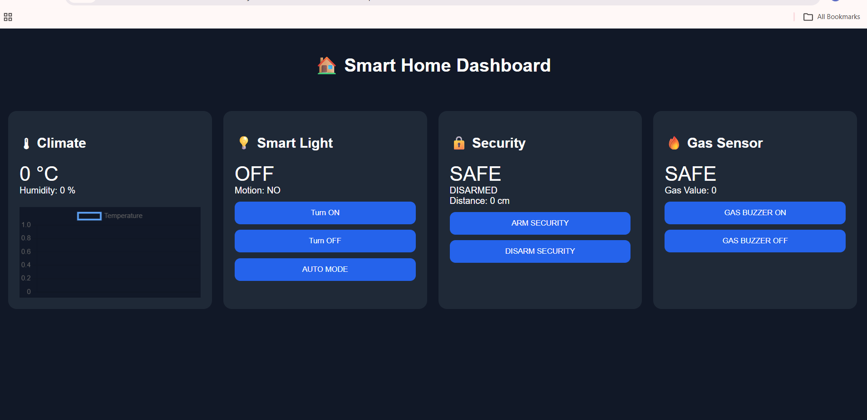

6. Distribution of Work Among Group Members
The smart home prototype project was developed collaboratively by both group members, and most stages of the work were completed together through continuous cooperation, testing, and problem solving. Although each member focused more on certain parts of the system, the implementation process was largely shared, and both participants contributed to the final result.
Andro mainly worked on the development of the security system, including the RFID authentication mechanism, ultrasonic sensor functionality, and buzzer alarm integration. He also worked on the DHT11 temperature and humidity monitoring system and participated in the physical construction and assembly of the XPS smart home model. Anano mainly focused on the development of the website interface, including remote control functionality and communication between the website and the ESP32 microcontroller. In addition, she worked on the lighting system and the organization and distribution of wires inside the smart home prototype.
Some important parts of the project were completed jointly by both members. The MQ2 gas sensor integration, system debugging, ESP32 programming, hardware connections, testing procedures, and overall system integration were shared responsibilities. During the development process, both members actively participated in troubleshooting hardware and software issues, improving system stability, and testing the interaction between different sensors and modules.
Overall, the project was completed through teamwork and collaborative effort, where both members contributed to the design, implementation, and improvement of the IoT smart home system.

7. Conclusion
The developed IoT smart home prototype successfully demonstrated the practical use of embedded systems, sensor technologies, and wireless communication within a single integrated platform. Although one of the goals of the project was to introduce and apply embedded systems concepts, the main objective was to achieve proper communication, connection, and integrity between multiple hardware and software components working together in real time. The project combined automation, environmental monitoring, lighting control, and security systems into one functional smart home solution controlled through a web interface.
During the implementation process, several technical challenges were encountered. One of the major difficulties was related to the quality and stability of the sensors and hardware components. Some sensors required very precise configuration and calibration in order to function correctly, and even small connection or programming issues could cause the system to stop working properly. There were multiple situations where the system operated successfully during testing but later experienced unexpected failures or unstable behavior, requiring repeated debugging and reconstruction of both hardware and software parts.
Despite these difficulties, the project team successfully managed to integrate all major modules into a working prototype. The experience provided practical knowledge in embedded systems programming, IoT communication, hardware integration, troubleshooting, and teamwork. In addition to the technical results, the project also demonstrated the importance of persistence, testing, and system stability in real-world engineering applications.
Overall, the smart home prototype achieved its intended functionality and proved that low-cost embedded systems and sensors can be combined to create an effective and interactive IoT-based home automation system.

9. List of Used Literature
[1] “Sensors Tutorial,” YouTube, uploaded by Electronoobs. [Online]. Available: https://www.youtube.com/watch?v=DlG6LY84MUU.
[2] PlatformIO Official Documentation.
[3] Espressif Systems ESP32 Documentation.
[4] Visual Studio Code Official Website.
[5] Arduino Sensors Interfacing Tutorial.

